Do YOU want to boost your general fitness and mental health in a fun, supportive environment?

Why not try the ECH Couch to 5K?

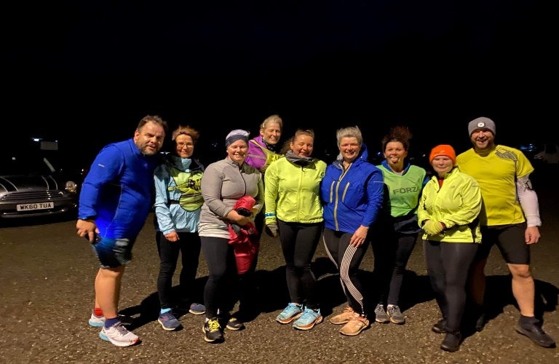
Week 1 start:

27th April Lux Park – 6.30pm

We follow the NHS tried and tested plan.

Weekly Wednesday sessions and plenty of support to achieve your goals (for 9 weeks and beyond).

No previous running experience necessary.

No charge! We are passionate about helping others to improve their health and wellbeing and offer this programme for free. You are welcome to join us for a 3-week trial and then we do encourage you to join our club (a standard member fee is £20 and gives you access to a variety of sessions for a whole year). Our membership fees fund leader qualifications and community events.

At East Cornwall Harriers, we understand that starting anything new can be very daunting. However, our qualified, friendly leaders will make you feel very welcome. If you have any queries, do not hesitate to contact
Lucy at : ladiescaptainech@gmail.com

Why not give one session a try?
You have nothing to lose but so much to gain!

