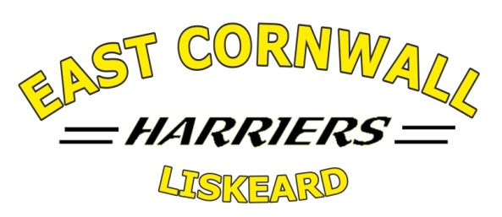
London Marathon Club Places
Draw Eligibility Form
To enter the club draw you must confirm that you satisfy the five criteria listed below and provide a copy of the form and your London Marathon ballot rejection notification to the Club Secretary.
Any member satisfying criteria 1-5 below who have been unsuccessful since the 2018 club draw (i.e. for the 2019 race) onwards and who re-apply, will have their entry to the draw multiplied by the total number of consecutive failures immediately prior to the current year.
If there are fewer eligible applicants than places awarded to ECH, then members who have previously run will also become eligible for the draw subject to satisfying criteria 2-5 below.

 |  |  | Please tick
1 | I have never run the London Marathon.
2 | I have been a fully subscribed member of East Cornwall Harriers for at least 12 months.
3 | I have applied to run in the London Marathon for the coming year and have been unsuccessful in the ballot. (Rejection notification attached)
4 | I have trained or raced with the club on at least 12 occasions during the previous 12 months
Please enter here how many consecutive times you have unsuccessfully entered for an ECH club place for the London Marathon since and including the ECH draw for the 2019 race.

Name: (Please print) _ _ _ _ _ _ _ _ _ _ _ _ _ _
Signature: _ _ _ _ _ _ _ _ _ _ _ _ _ _ _
Date: _ _ _ _ _ _ _ _ _
Good luck in the draw!
Revised October 2022

