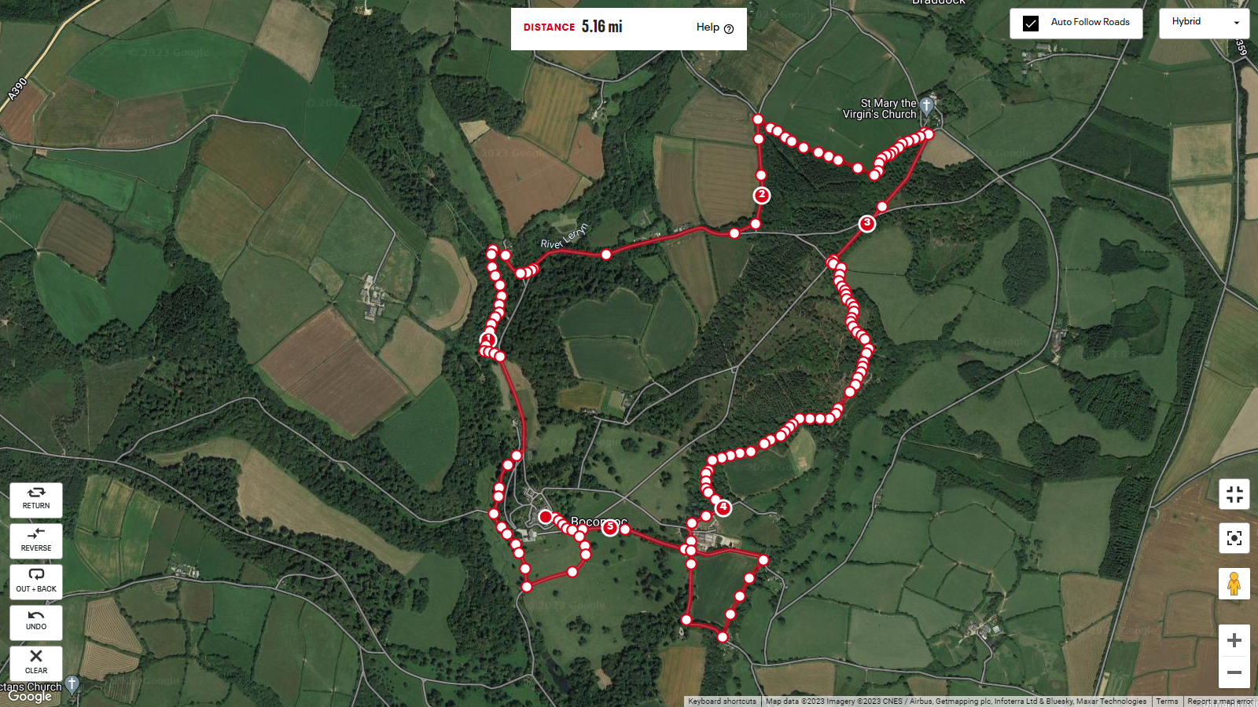

Water  
Station

Start / Finish

CAUTION!  
River Crossing

5 Miles

4 Miles

1 Mile

2 Miles

3 Miles

Boconnoc 5 mile Course Plan

A beautiful country estate 5mile multi-terrain run with a mix of woods, footpaths and country lanes