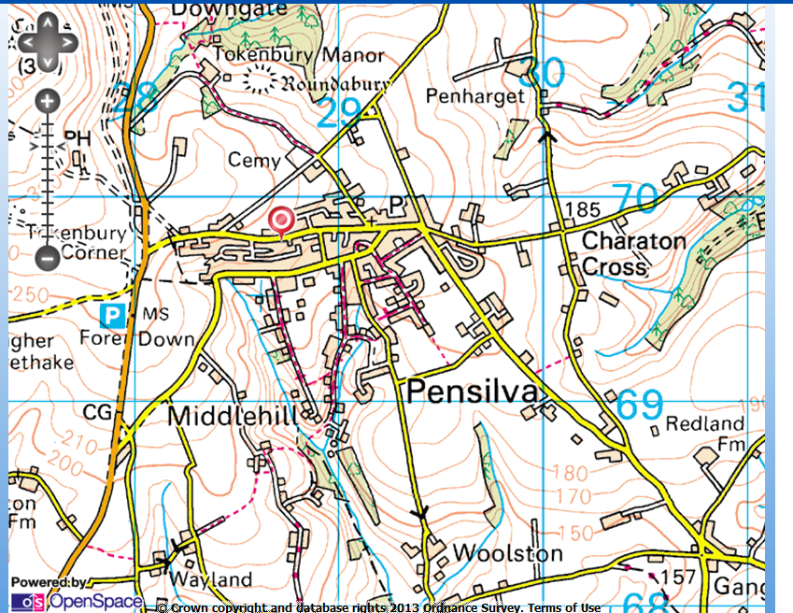
Race Start/Finish Parking
Car Parking

